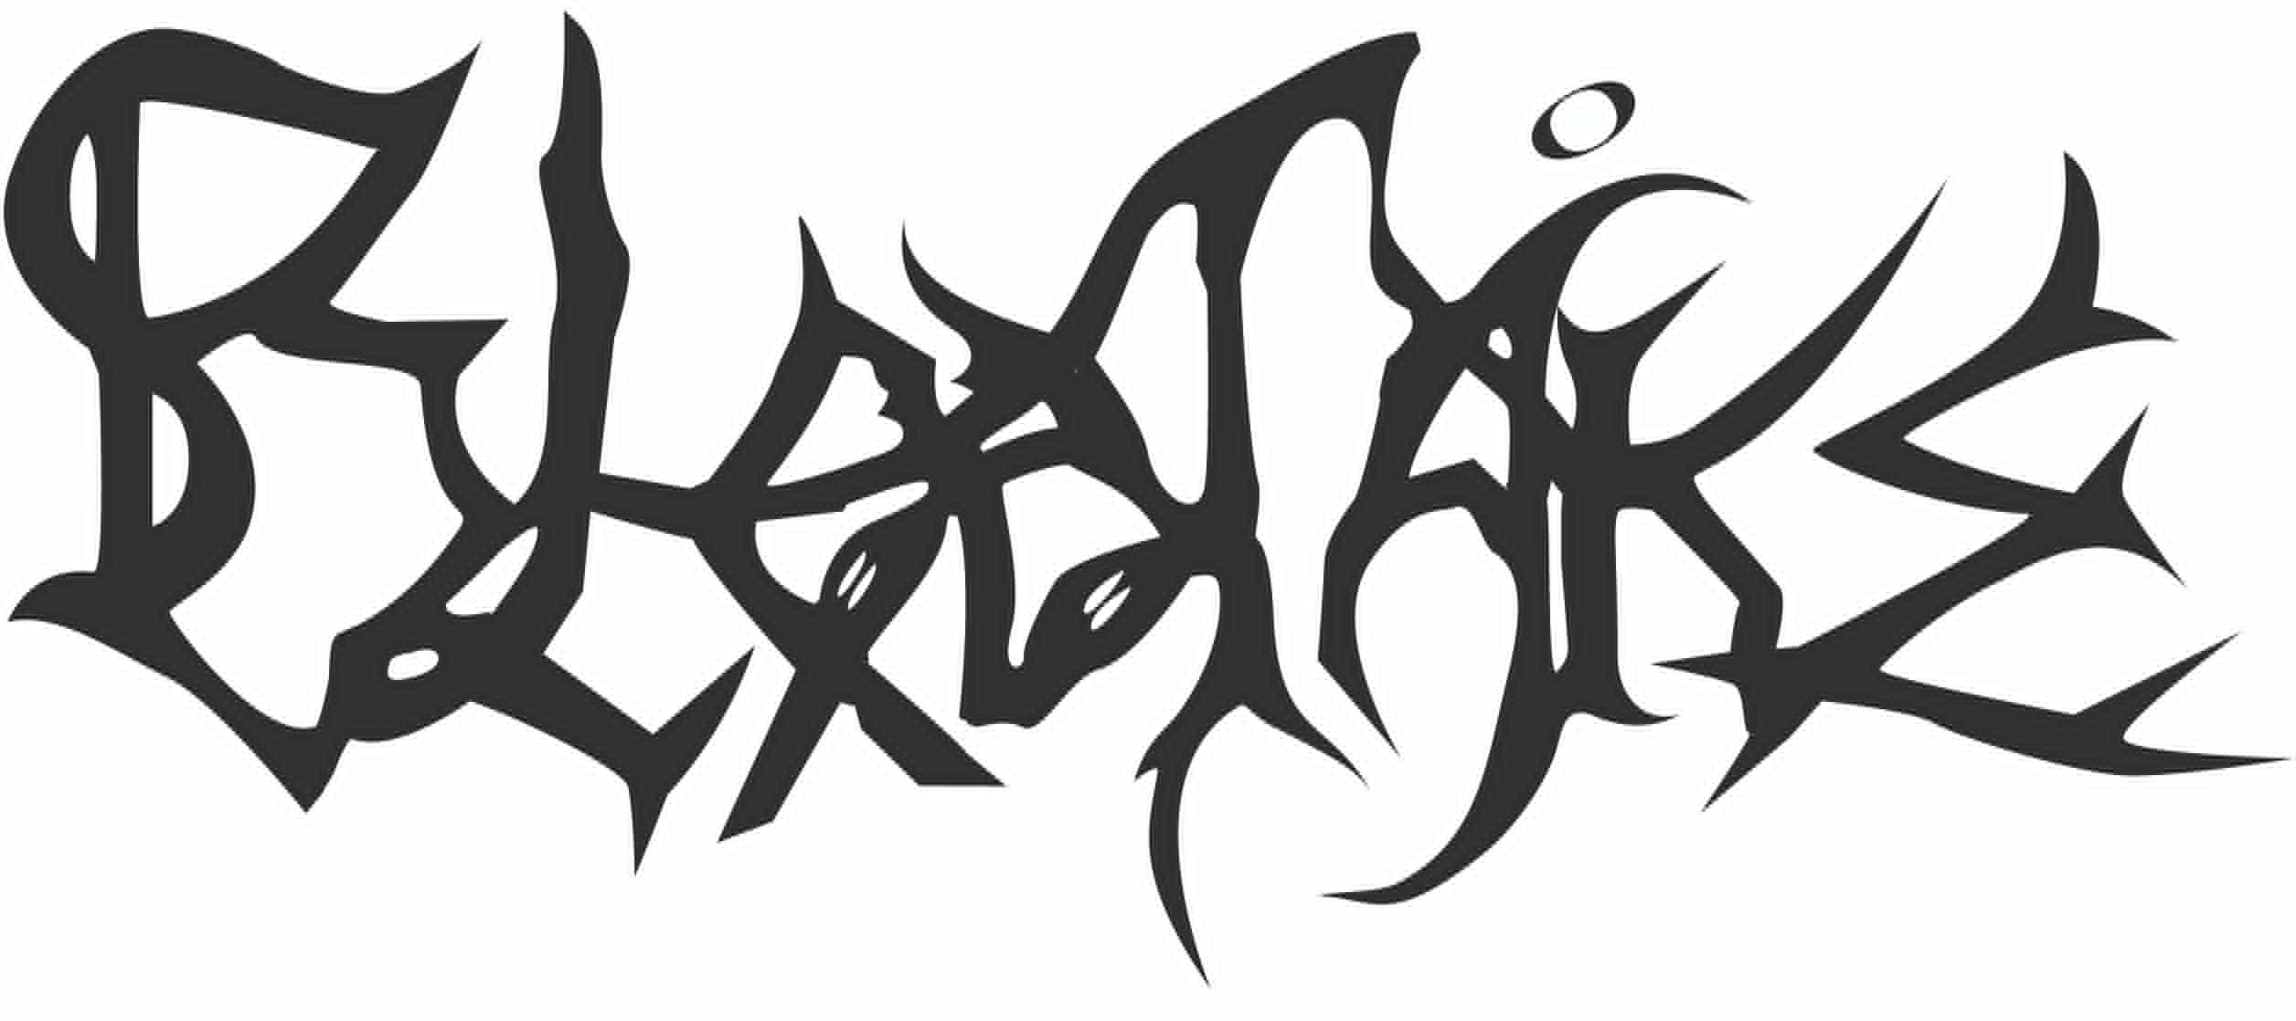
Blodtåke are deeply rooted in black metal and extend into death, doom and progressive metal. Blodtåke's goal is to make pain, wounds, frenzy and melancholy so tangible for the listener that they lose themselves in it. The name Blodtåke (English: blood fog) describes a similar effect, the loss of all self-control, e.g. when a hunter pursues his prey or a murderer kills his victim - without fear of consequences.
With “Nativity of ashes” the five experienced musicians presented their debut album. Recorded by Andy Classen at the renowned Stage One Studio, the songs are split across two sides - similar to a traditional LP - and take the listener on a journey from dying confidence to obsidian-black ash. Accompanied by concept artwork that captures the mood of the songs, “Nativity of ashes” already hints at the live violence the quintet makes the songs and emotions palpable from the stages.
"Nativity of ashes" is available as a high-quality 3-panel digipack with a 16-page booklet as well as a digital download on Bandcamp and streams on all common platforms.
The band is working at full speed on their second album, which is about to explore the extremes between genres even further while still remaining true to Blodtåke's unmistakable sound.

Blodtåke are:
Yall - Vocals
Gråven - Guitar
Orm - Guitar
Thylraz - Bass
Scriostóir – Drums

E-Mail and interview contact: info@blodtake.de
Booking request: booking@blodtake.de
Social media: www.facebook.com/blodtake
Presskit download: https://promo.blodtake.de/EPK/
Album und Merchandise: www.blodtake.bandcamp.com

